|  |  |
| --- | --- |
|  |  |
| Analyzing Travel Insurance Data |  |
|  |  |
|  | 18/10/2021Wireframe Document |
|  | Anshul PandeyiNeuron Intelligence Pvt Ltd |

Contents

Analyzing Travel Insurance Data 1

Data Model 3

Main Dashboard 4

High Level KPI’s 5

Low Level KPI’s with more granular demographics 5

### Data Model

### 

### Main Dashboard

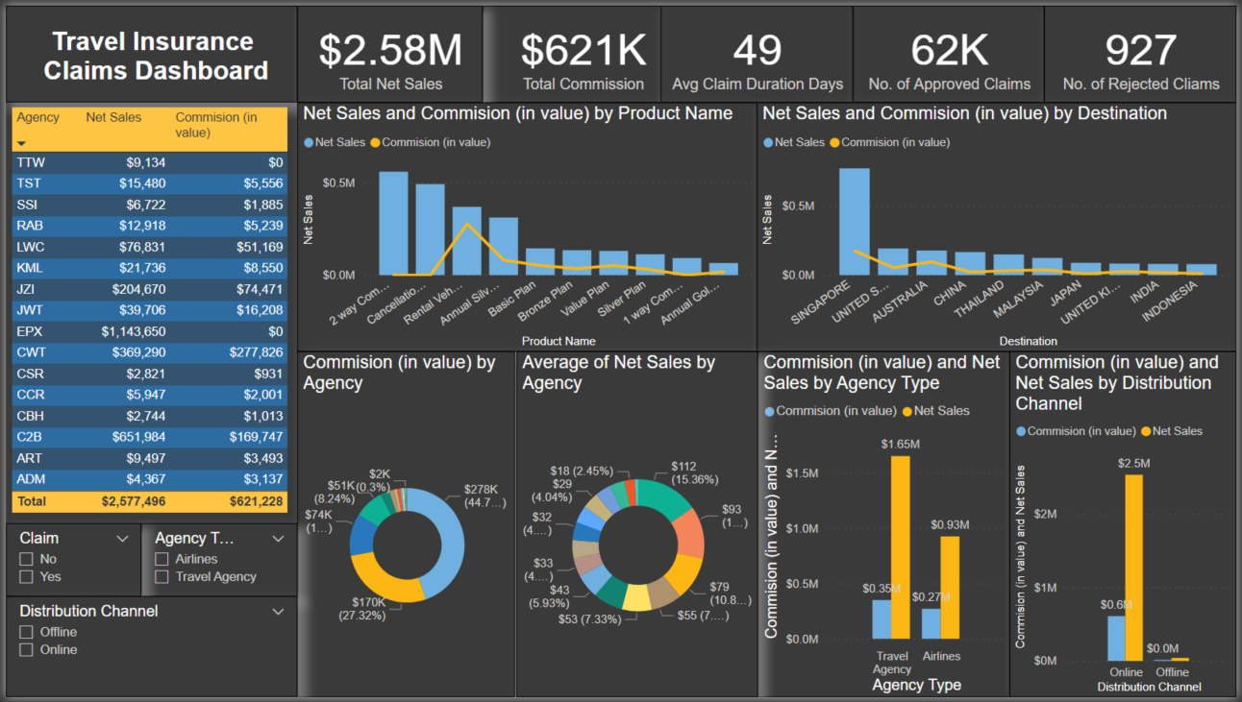

### High Level KPI’s

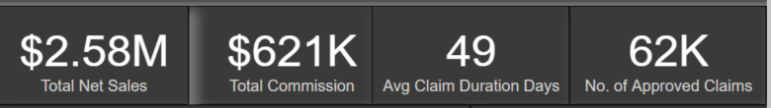

### Low Level KPI’s with more granular demographics

#### Relation Between Agency, Net Sales and Commission

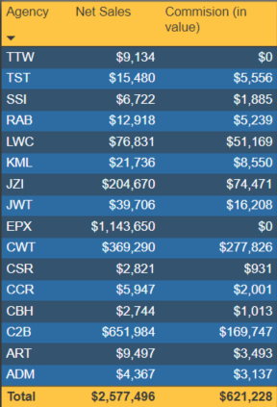

#### Relation Between Product Name, Net Sales and Commission

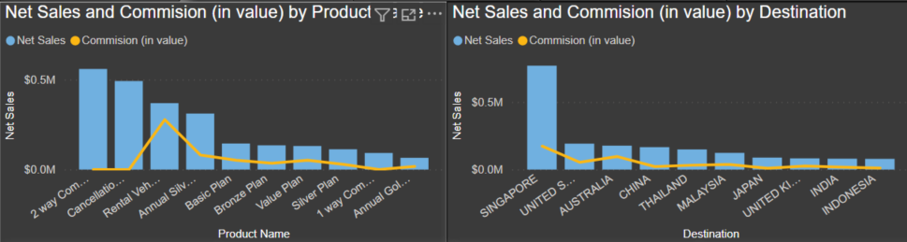

#### Relation Between Agency, Net Sales and Commission and Average

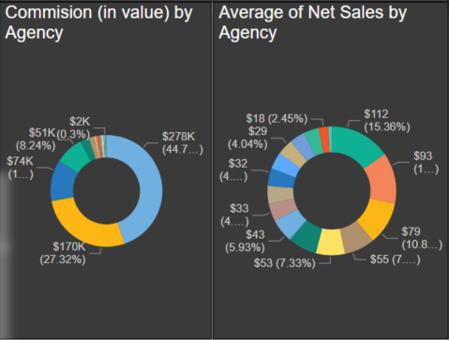

#### Relation Between Agency Type, Distribution Channel with Net Sales and Commission and Average

